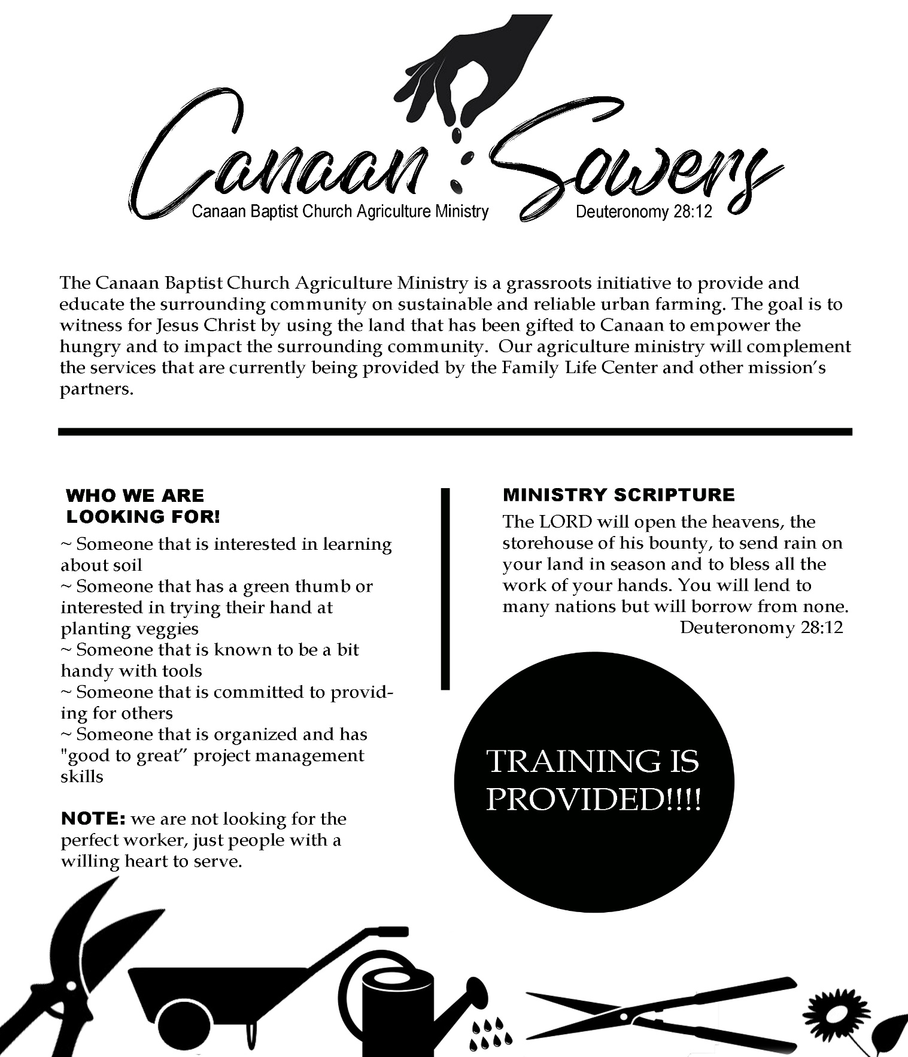

**NEW MINISTRY**

Canaan has launched an Agriculture Ministry! This is a grass roots initiative to provide and educate the surrounding community on sustainable and reliable urban and micro farming. The goal is to provide a witness for Jesus Christ by teaching skills that will empower our neighbors to grow their own food. Additionally, neighbors in need will receive free fruits and vegetables. Lastly, the ministry will complement the services being provided by the Family Life Center and other mission’s partners. Please contact Mr. Anthony James through the church office 215-848-6311 Ext 02 or [contactanthonyjames@gmail.com](mailto:contactanthonyjames@gmail.com).